Creating a Web Album for a Hike Report with Google Photos

By: Marilyn Warrant
December 2016

If you want to use the free upload & storage offered by Google Photos, resize your photos to a maximum of 2000 pixels x 1500 pixels (ratio 4 x 3), 1500 x 2000 pixels (ratio 3 x 4), or 2000 x 2000 pixels (square). Make sure the photos are sorted in time order in the folder (that's the default). This size is also acceptable for uploading to the ASCHG website, such as for a hike description representative photo (by hike maintainers) or for a flower photo (any hiker).

First, get a Google account. Go to URL https://accounts.google.com/SignUp?hl=en. If you already have a gmail account, that works too.

Once you have an account, go to URL https://photos.google.com/albums. If you don't want any additional features, click on "More Options" then "No Changes."

After the first time, go to URL https://photos.google.com/albums then sign in. Your albums will be displayed. Your albums should include albums you uploaded with Picasa or Google +, as well as with Google Photos. (An exception is when you used your name as part of the link in Picasa; those aren't being redirected.)

Click on the blue "Upload." A window will open showing your files. Select the first photo for your new album and click on Open.

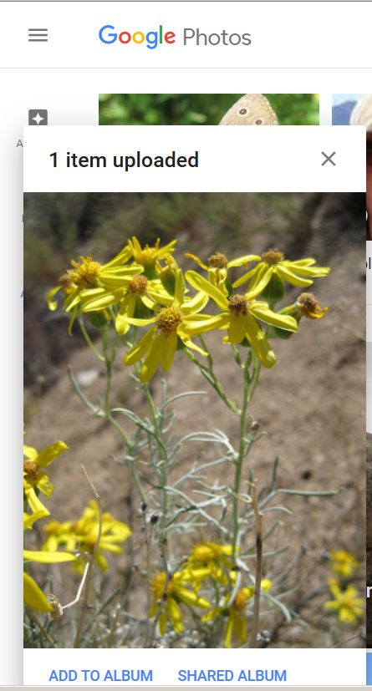

You'll see the photo with some blue text in the lower left of your screen. Click on "Add to Album", then click on the first choice "New Album."

The photo is displayed in a new screen with your cursor at the beginning of text "Untitled." Add the title you want for the web album (such as the date and the hike name).

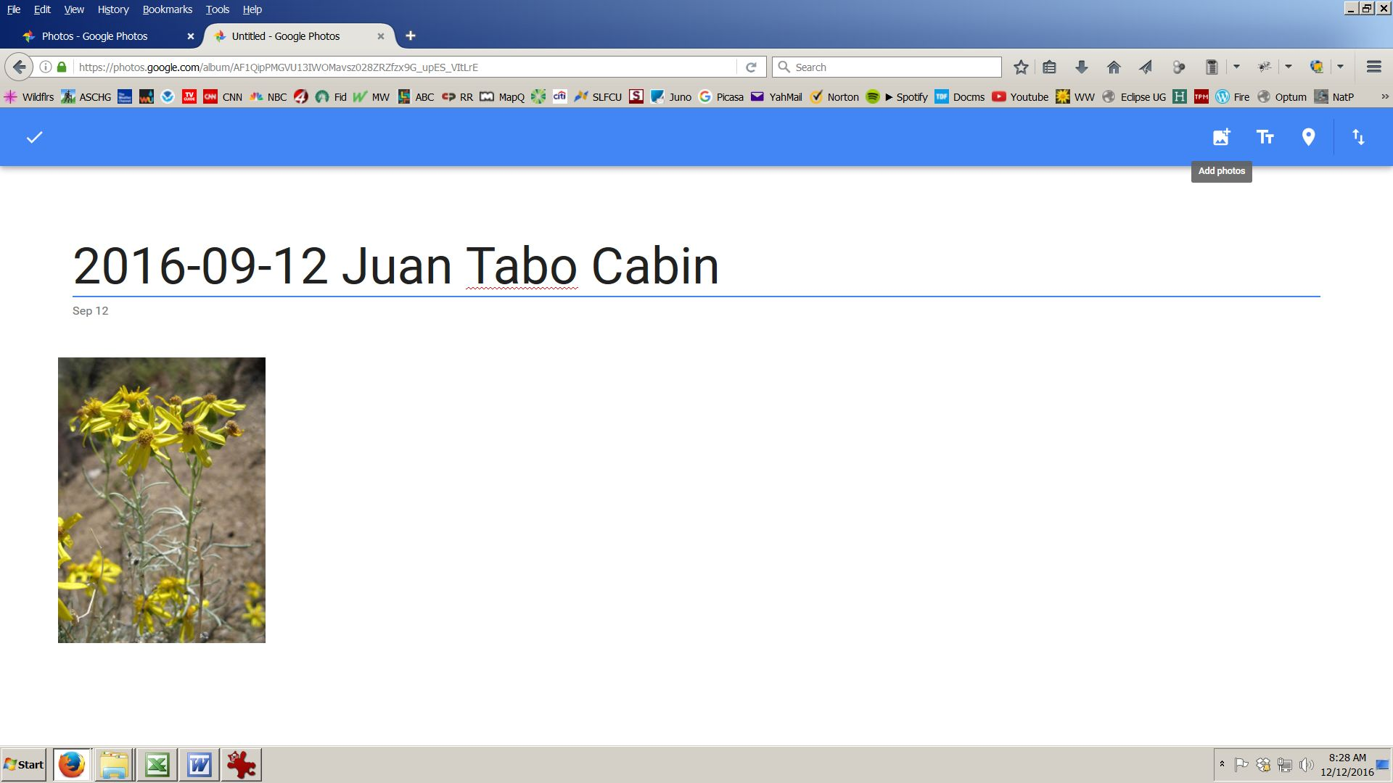

To upload the rest of your photos, click on the left symbol on the upper right of your screen (it includes a +). Choose "Select from Computer." Select all the photos you want to upload, then click "Open." The photos will be uploaded one by one as shown in the window in the lower left of your screen. Click on the blue CONTINUE.

If for some reason one or more photos are skipped, write down their filenames, then select and upload them again. The second time usually works.

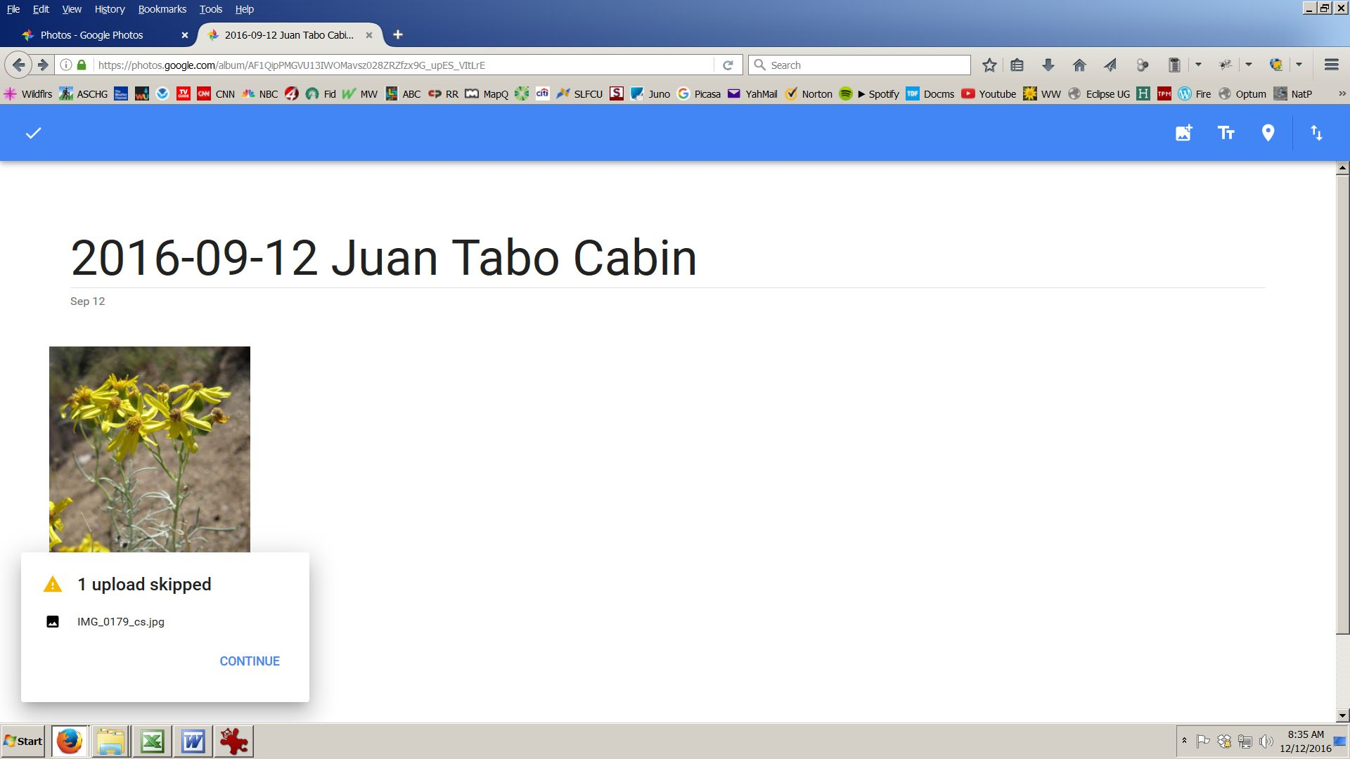

When you've finished uploading photos, click on the white checkmark on the upper left of your screen.

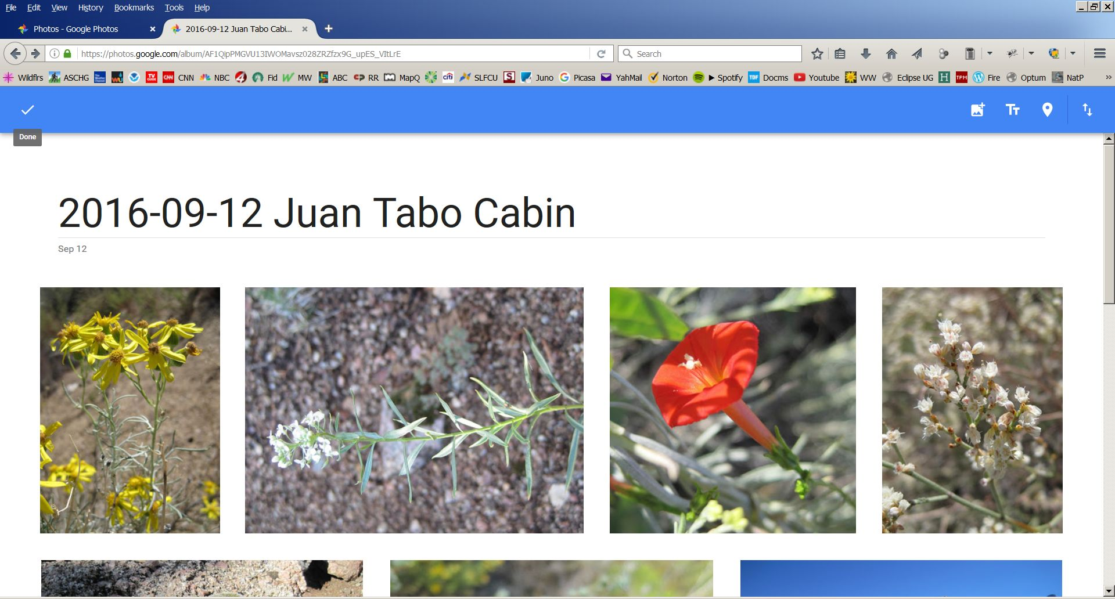

Now you're ready to find the link to share your web album. Notice that the icons on the upper right of the screen have changed.

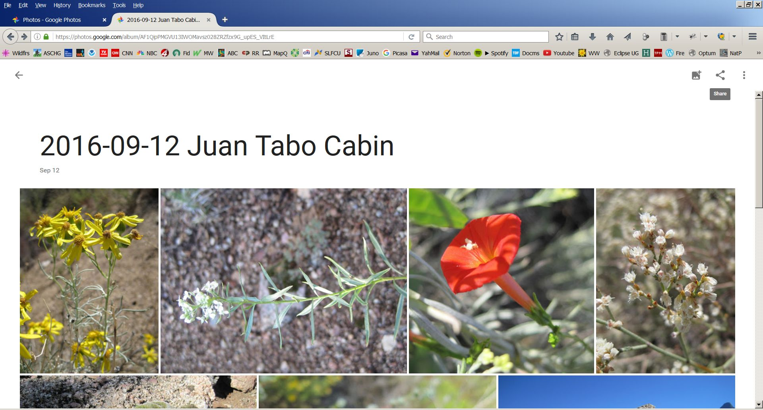

Click on the 3 dots that look like a wedge (the middle symbol -- Share).

Click on "Get Link."

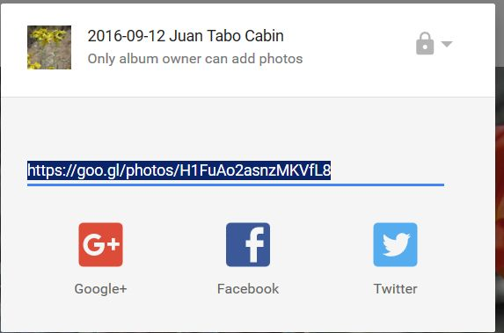

Copy the link that is displayed (Ctrl-C on a Windows computer) and paste it in an email message to the hike leader.

If you want to edit a photo, click on it. To edit light & color or crop the photo, click on the pencil symbol. To rotate the photo or remove it from your album, click on the symbol on the far right on the upper right of your screen that is 3 stacked dots "More Options."

